**Technology Review**

Some of the modern GUI languages are C#, Python, C++, and Java. C# is mainly used for windows applications, while Python, C++ and Java are cross-platform. These languages have different frameworks that helps with the development of the user interface, for instance Python has Tkinter, PyQt5 and Kivy, each of these frameworks have its advantages when developing an UI, being Tkinter the most popular one due to its level of customization. For C++ we can find Qt, wxWidgets, JUCE, CEGUI, and CEF. For Java we can use AWT, Swing and JavaFX, being JavaFX the most popular one nowadays, while AWT and Swing are more of a legacy framework. For this project, I need to use one language that offers a balance between functionality and design, in this case C# is the best one as it offers great possibilities for design.

We have also to consider the IDE (integrated development environment) of each language, for C# we have Visual Studio which is without a doubt the best IDE for this language, its grab and drop system for the GUI part makes Visual Studio easy to use. For Python we have PyCharm which is perfect for testing and for uploading the code to GitHub. And for the other languages Visual Studio Code can be used as it is relatively easy to use and support several programming languages. As I said before, both Python and C# have great IDEs but for the purpose of this project, Visual Studio is the best because for the development of the user interface it offers the option of grabbing the objects and paste them on the form.

For storing the data, we have several options such as MySQL, Microsoft Access, and OpenOffice Base, which are all local databases. For server like databases, we have Azure MySQL, Amazon Aurora, and MongoDB Cloud. For this project, Microsoft Access is the best as it meets the requirements, and it is compatible with C#.

As for similar projects done in the past, we have this project which have similar use cases as the ones describe in the Saint Albert project. Here are some screenshots from that project.

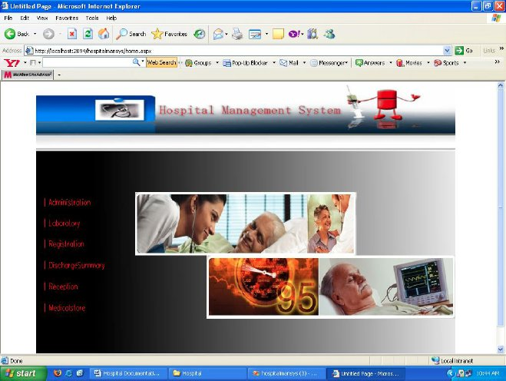

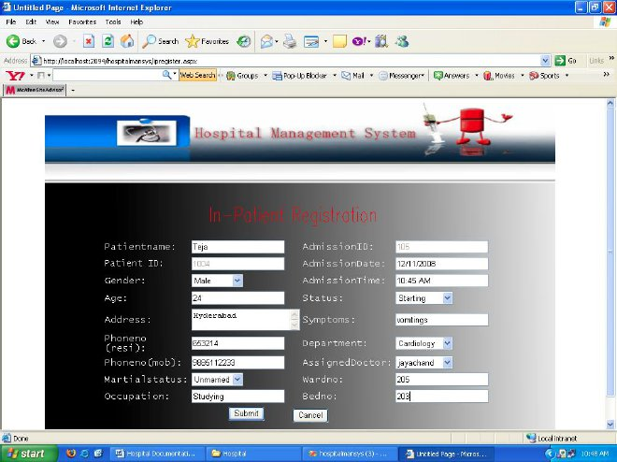

[Top 10 Programming Languages for Desktop Apps In 2021 (decipherzone.com)](https://www.decipherzone.com/blog-detail/top-programming-languages-for-desktop-apps-in-2021)

[Top 10 Python GUI Frameworks for Developers | by Claire D. Costa | Towards Data Science](https://towardsdatascience.com/top-10-python-gui-frameworks-for-developers-adca32fbe6fc)

[5 Cross-Platform GUIs for C++ (dice.com)](https://insights.dice.com/2016/11/18/5-cross-platform-guis-for-c/)

[Java GUI Frameworks Guide - CodersLegacy](https://coderslegacy.com/java-gui-frameworks-guide/)

[MySQL :: MySQL 8.0 Reference Manual :: 1.2.1 What is MySQL?](https://dev.mysql.com/doc/refman/8.0/en/what-is-mysql.html)

[Usability Evaluation of Three Admission and Medical Records Subsystems Integrated into Nationwide Hospital Information Systems: Heuristic Evaluation (nih.gov)](https://www.ncbi.nlm.nih.gov/pmc/articles/PMC6029901/)

[Best Online Database Software 2021 | Project-Management](https://project-management.com/online-database-software/)

[Hospital Management System ASP.NET Project | Code with C](https://www.codewithc.com/hospital-management-system-asp-net-project/)